ATMOSPHERE and CLIMATE HISTORY: WALL CONTENT

FOR WALLS

Content is added below in order, images for each point are below content for each point.

1)The Earliest Atmosphere

(4.6 billion years ago)

When Earth formed 4.6 billion years ago from a hot mix of gases and solids, it had almost no atmosphere. The surface was molten. As Earth cooled, an atmosphere formed mainly from gases spewed from volcanoes. It included hydrogen sulfide, methane, and ten to 200 times as much carbon dioxide as today’s atmosphere. After about half a billion years, Earth’s surface cooled and solidified enough for water to collect on it.

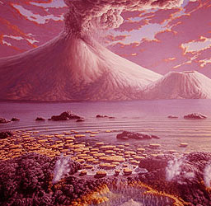

2)

2)The Archean Eon (4 to 2.5 billion years ago)

During the Archean Eon, methane droplets in the air shrouded the young Earth in a global haze. There was no oxygen gas on Earth. Oxygen was only in compounds such as water. Complex chemical reactions in the young oceans transformed carbon-containing molecules into simple, living cells that did not need oxygen to live. Instead they made energy out of sulfur and other elements.

2.7 billion years ago, bluish-green microscopic organisms called cyanobacteria flourished in Earth’s oceans. They made gaseous, or free, oxygen from carbon dioxide, water, and sunlight—the process called photosynthesis. As cyanobacteria created more free oxygen, the amount of oxygen in the atmosphere reached one percent of today’s level, which is 21 percent

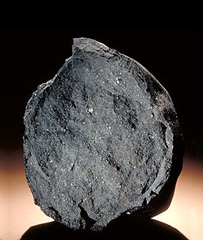

3) 3)Life and Earth’s atmosphere evolved together. Over time, tiny photosynthetic organisms produced enough oxygen to react with the methane in the atmosphere, transforming it forever. About two billion years ago, the methane haze cleared and the sky turned blue.

After photosynthetic bacteria had been making oxygen for about 300 million years, enough oxygen built up in the atmosphere to oxidize (combine with) the iron in rocks and soil to make reddish iron oxide and create vast expanses of redbeds. Scientists study redbeds to learn more about Earth’s early atmosphere.

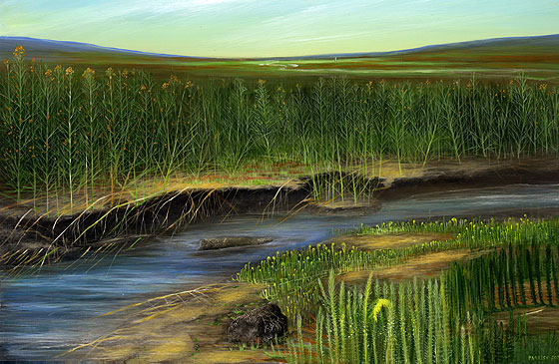

4)

4) Oxygen Boom!

Between 700-550 million years ago, in the late Proterozoic, oxygen levels in the oceans and atmosphere increased dramatically. By 600 million years ago, the oxygen in the atmosphere reached about one-fifth of today’s level (21 percent). The oxygen boom favored the evolution of lifeforms that could use oxygen to create energy. For other organisms, oxygen was poisonous, and they were forced into extreme airless habitats or into extinction. Some scientists say that the increase in oxygen helped fuel the burst of sea life known as the Cambrian explosion, 530 to 509 million years ago, including the evolution of eurypterids and trilobites.

Until about 430 million years ago, most aerobic organisms lived in the ocean and used oxygen dissolved in seawater. Then about 430 million years ago, life on land appeared. Small plants and invertebrates (animals without backbones) evolved the ability to live on land and use oxygen directly from the atmosphere. During the Devonian Period, 416-397 million years ago, plants evolved, as did the first four-footed animals.

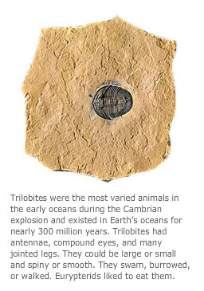

5)

5)The Age of Oxygen (400 million to 290 million years ago)

As plants became firmly established on land, life once again had a major effect on Earth’s atmosphere during the Carboniferous Period. Oxygen made up 20 percent of the atmosphere—about today’s level—around 350 million years ago, and it rose to as much as 35 percent over the next 50 million years.

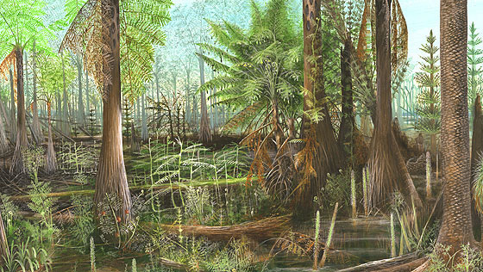

6)

6) Modern Atmospheres (290 million years ago to now)

During most of the past 290 million years, Earth was much warmer than it is now. Scientists understand that changes in the atmosphere affect Earth’s climate. Between 200 and 45 million years ago polar ice caps were small or absent, and winters were warmer around the globe. In these warm climates, many types of plants and animals lived in the polar regions.

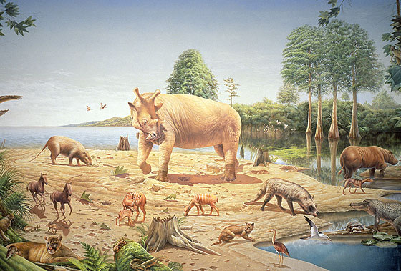

7) 7) What we call the atmosphere comes in five main layers.

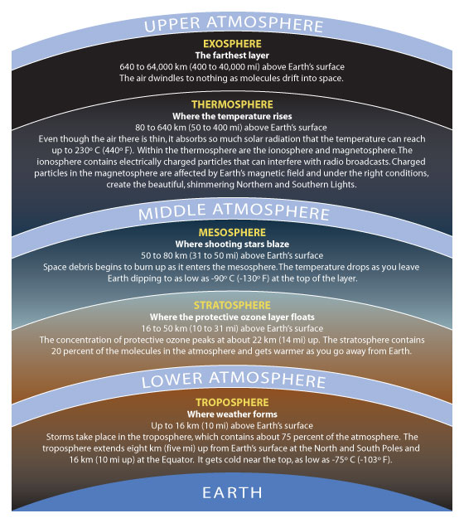

8) 8) Today, the earth's atmosphere has the following composition:

Molecules in the air include primarily nitrogen and oxygen as well as water, carbon dioxide, ozone, and many other compounds in trace amounts, some created naturally, others the result of human activity.

In addition to gases, the atmosphere contains extras such as smoke, dust, acid droplets,

and pollen.

The composition of the atmosphere changes constantly and depends on the season, weather, time of day, latitude, longitude, elevation, and geography.

